**Overview**

This is an analysis of a fictional employee attrition and performance dataset from Kaggle. Understanding what factors lead to employee attrition is important for companies as it helps them understand what their employees might be struggling with so that they can retain their talented employees.

The dataset includes features about employee demographics and their work-related data such as age, gender, education, monthly income, job satisfaction, etc.

**Data Validation**

The dataset contains 35 columns and 1470 rows, all complete with no missing values. Since the source doesn't provide column details, I've attempted to describe them based on context.

1. Age: Age of the employee.
2. Attrition: Whether the employee has left the company (Yes/No).
3. BusinessTravel: Frequency of business travel (e.g., Travel_Rarely, Travel_Frequently).
4. DailyRate: Daily rate of pay for the employee.
5. Department: Department in which the employee works (e.g., Sales, Research & Development).
6. DistanceFromHome: Distance of the employee's home from the workplace.
7. Education: Level of education attained by the employee (1: 'Below College', 2: 'College', 3: 'Bachelor', 4: 'Master', 5: 'Doctor').
8. EducationField: Field of education of the employee.
9. EmployeeCount: Number of employees (usually constant for all rows).
10. EmployeeNumber: Unique identifier for each employee.
11. EnvironmentSatisfaction: Satisfaction level with the work environment.
12. Gender: Gender of the employee.
13. HourlyRate: Hourly rate of pay for the employee.
14. JobInvolvement: Level of involvement in the job.
15. JobLevel: Level of the employee's job within the company.
16. JobRole: Role or position of the employee.
17. JobSatisfaction: Satisfaction level with the job.
18. MaritalStatus: Marital status of the employee.
19. MonthlyIncome: Monthly income of the employee.
20. MonthlyRate: Monthly rate of pay for the employee.
21. NumCompaniesWorked: Number of companies the employee has worked for.
22. Over18: Whether the employee is over 18 years old (Y/N).
23. OverTime: Whether the employee works overtime (Yes/No).
24. PercentSalaryHike: Percentage increase in salary for the employee.
25. PerformanceRating: Performance rating of the employee.
26. RelationshipSatisfaction: Satisfaction level with work relationships.
27. StandardHours: Standard number of working hours per week.
28. StockOptionLevel: Level of stock options granted to the employee.
29. TotalWorkingYears: Total number of years the employee has worked.
30. TrainingTimesLastYear: Number of training sessions attended by the employee last year.
31. WorkLifeBalance: Perceived balance between work and personal life.
32. YearsAtCompany: Number of years the employee has been with the company.
33. YearsInCurrentRole: Number of years the employee has been in their current role.
34. YearsSinceLastPromotion: Number of years since the employee's last promotion.
35. YearsWithCurrManager: Number of years the employee has been with their current manager.

The first 5 columns and the first 6 rows of the dataset.

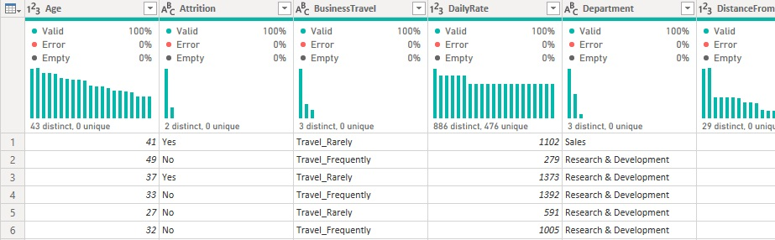

**Data Transformation**

1. Created Dax Measures to calculate attrition rate, number of active/inactive employees, average monthly income, and total number of employees. We will use these measures to create insightful visualizations.

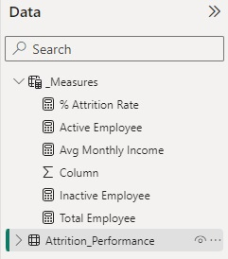

1. Created age and monthly income bin columns, as the original columns had too many different values. Grouping them into bins helps us better see insights across different age and income groups.

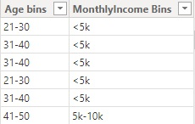

**Data analysis**

Overview:

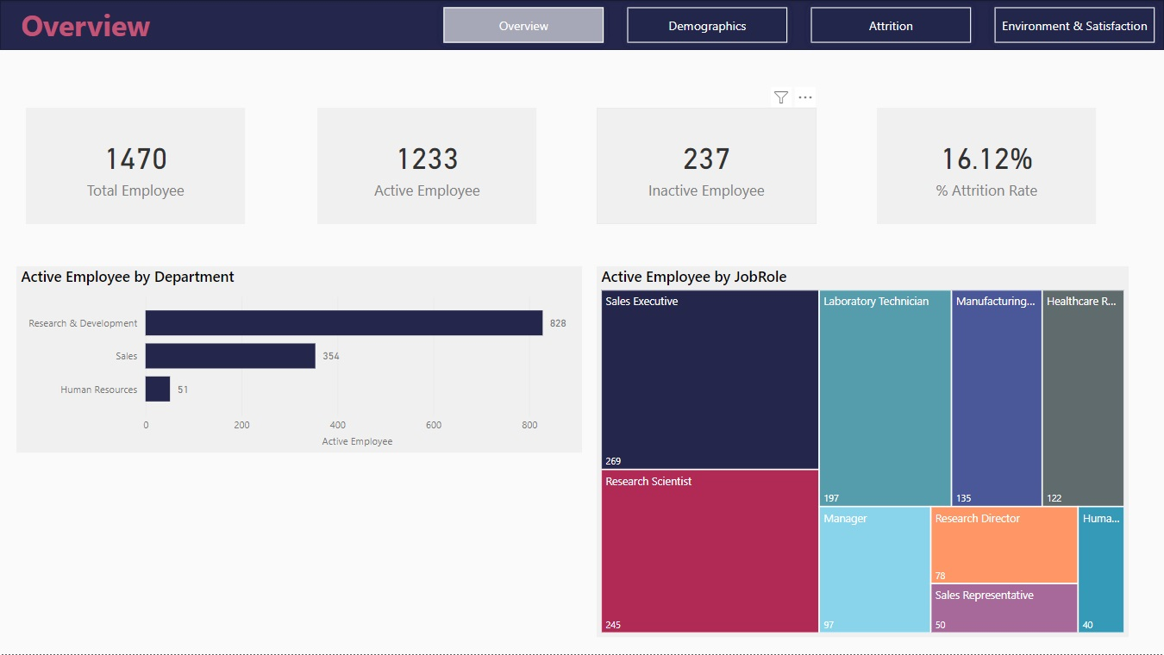

1. Total number of employees is 1470 with active employees of 1233 and employees who left the company is 237. The attrition rate is **16.12%**.
2. **R&D department has highest number of employees** which takes up around 67.15% of total active employee followed by sales, and HR department
3. Top three job roles by number of employees are **sale executive, research scientist, and laboratory technician.**

Demographics:

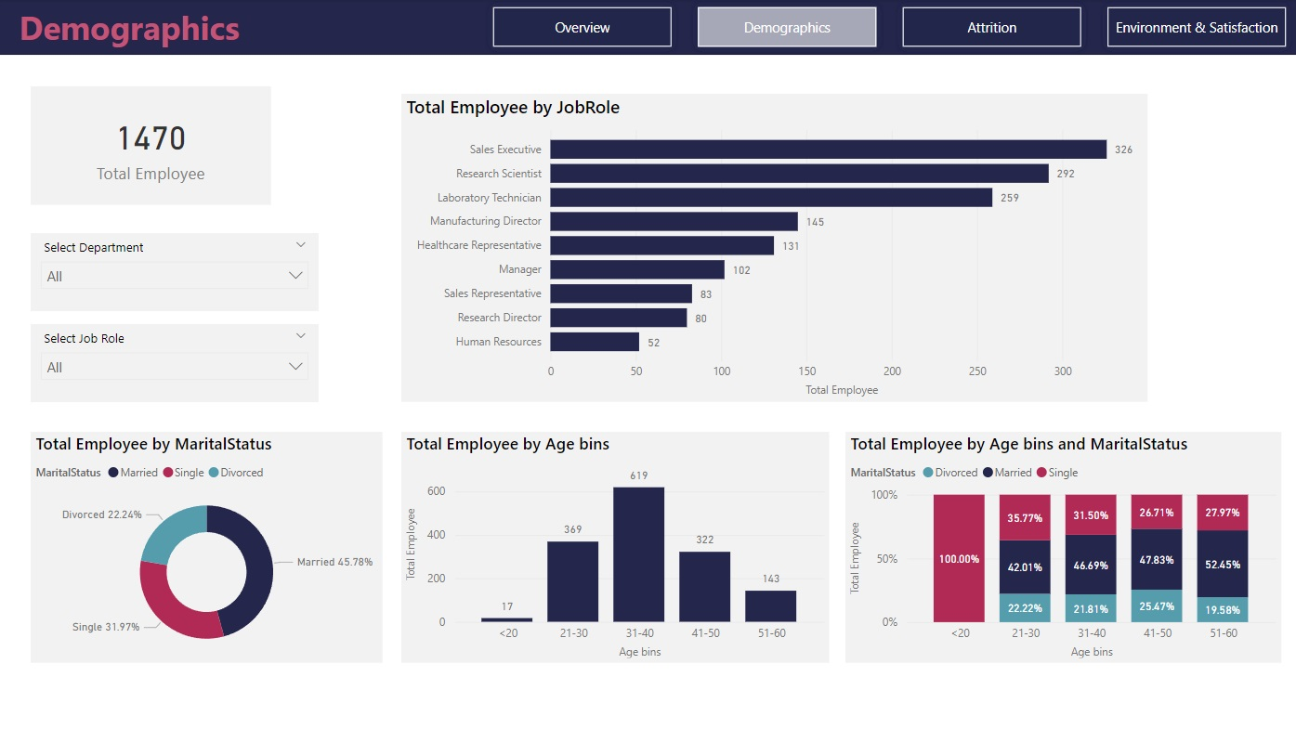

1. The top three job roles with the highest number of employees are **sales executive**, followed by research scientist, and then laboratory technician.
2. Attrition rate of employees who are **married is 45.78%** followed by single 31.97% and divorced 22.24%
3. The company has the most employees in **the age range of** **31-40**, with a total of 619 employees.

Attrition:

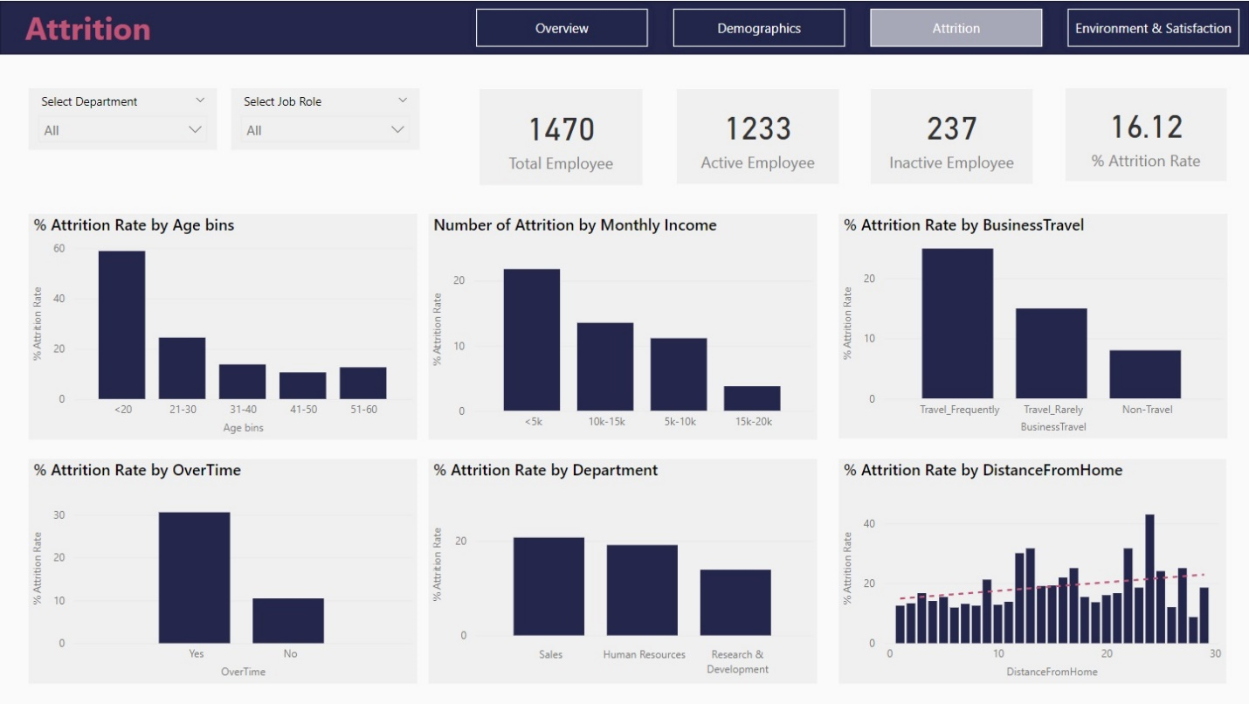

1. Employees **under the age of 20** have the highest attrition rate, at **58.82%**.
2. Employees with a **monthly income below $5,000** have the highest attrition rate, at **21.76%**.
3. Employees who **frequently travel for business** have the highest attrition rate, at **24.91%**.
4. Employees who **work overtime** have the highest attrition rate at **30.53%**.
5. **Sales department** has the highest attrition rate with **20.63%** followed by human resources at 19.05%, and research & development at 13.84%.
6. Employees who **live farther from the company** have a higher chance of leaving.

Environment & Satisfaction:

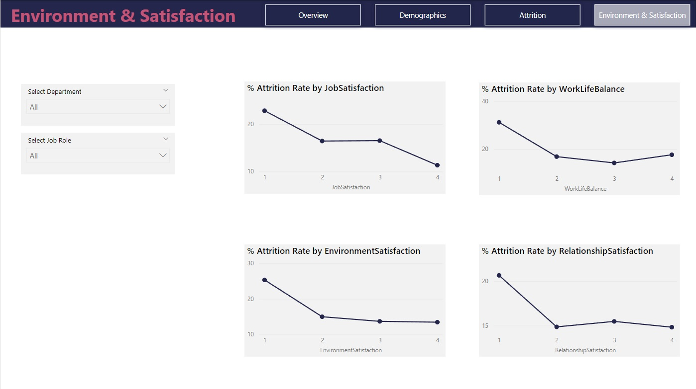

1. Employees with **the lowest satisfaction scores (1)** are most likely to leave the company, regardless of the area (job satisfaction, work-life balance, environment, or relationships).